SANIMAL – Scientific Animal Image Analysis

David Slovikosky

**Background:**

In May 2016 I was made aware that the School of Natural Resources and the Environment (*SNRE*) department at the University of Arizona was using outdated software to analyze images taken by camera traps. These motion detector-equipped cameras are set up in the wild and are left to take pictures for many months. After being retrieved, the images are collected and sorted by various researchers from high school students, to university professors, to retired people who do it as a hobby. Images are sorted or *tagged* by hand with GPS location, species, and number of animals. These researchers then aggregate their data into collections which are manually stored on hard drives or servers. Finally, analysis software is run on the tagged data to produce meaningful output used for research.

Originally this task was accomplished with a suite of FORTRAN programs written by Dr. Jim Sanderson. The heart of this software suite is made up of two programs, *DataOrganize* and *DataAnalyze*. *DataOrganize* is used to sort image metadata into an easily pasrable format, which is then followed by *DataAnalyze* which takes sorted data as input and creates a large text file as output. This *output.txt* file contains thousands of lines of summary statistics on the data in the form of ASCII charts which is heavily used by the SNRE department. A sample screenshot of this output is shown below:

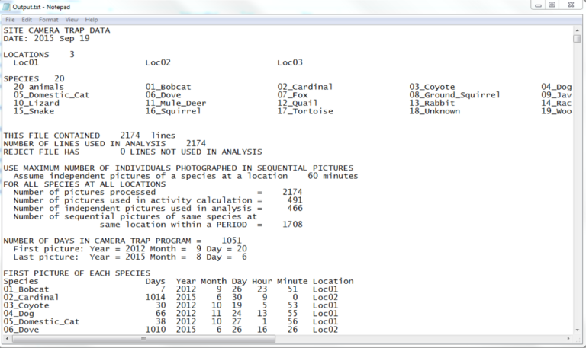

This software package has been used for many years and is currently kept up-to-date by Dr. Sanderson. Updates are released as researchers find bugs in the existing calculations or define a new analysis they would like to see. Unfortunately, this software leaves much to be desired. More specifically, *DataOrganize* and *DataAnalyze* are lacking in the following areas:

1. The source code is in FORTRAN and not easily available for custom modification
2. The sorting process for data is very tedious
3. Command line execution of the program can easily crash if the inputs are incorrectly formatted without any error description of what went wrong
4. Output is in text format only and can be challenging to parse
5. Analysis can only be performed on local data making it difficult to collaborate

***DataAnalyze* and *DataOrganize* Deficiencies:**

*(1) DataAnalyze* and *DataOrganize* is written in FORTRAN and the source code is currently private. While FORTRAN was a cutting-edge language at its time, it has aged and does not provide many features standard in modern languages. Most importantly, it is challenging to create a user interface in FORTRAN which is essential in modern applications. Because the software is closed source, any modification to either program is impossible. This means there is no way to see how any of the analysis are done besides the documentation given by Dr. Sanderson. While this documentation does give some insight on how the numbers are computed, it can be difficult to reverse engineer many of the numbers.

(2) As previously stated, images taken on camera traps must be *tagged* with location, species, and animal count. Locations are comprised of a name and UTM coordinates. Species are given by a name, and finally count specifies the number of the species in the image. The image date and time taken must also be extracted from the image metadata. *DataOrganize* performs this *tagging* process by parsing a directory structure as well requiring an external tool to extract image date and time taken. The *tagging* process begins by renaming all images in the following format: “Year Month Day Hour Minute Second.jpg” by a third-party program named “Renamer”. This software simply reads the image file metadata and renames the file accordingly. All credit for this program is found below:

https://www.den4b.com/products/renamer

Renamed images are then copied into a directory structure pictured below (taken from Dr. Sanderson’s HowTo slides):

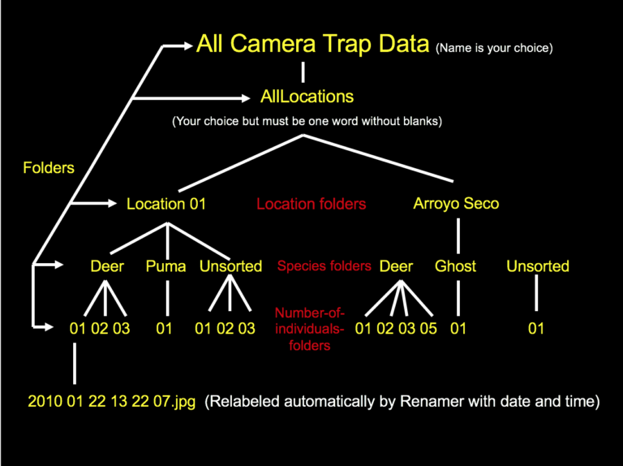

This directory structure is then parsed by *DataOrganize*. Location UTM coordinates are read in from a separate file which is provided as a standard-in argument. These coordinates must be in a very specific format to be parsed correctly, otherwise the FORTRAN software will crash. After a few seconds of execution, *DataAnalyze* creates a few output text files, of which *output.txt* contains most of the analysis. This entire process of renaming the images and then copying them into a multi-layer directory structure is incredibly tedious and lacks scalability. Images that contain multiple species are duplicated in the directory structure leading to data redundancy.

(3) *DataAnalyze* and *DataOrganize* are Windows executables which is run from the command line. This immediately poses a problem to anyone using a Mac or Unix based system, because they simply cannot use the software. Users must open a terminal and answer questions asked by the software such as, “Enter folder name containing all camera trap locations, then ENTER”. There are many challenges when using command line applications especially to users who lack technical knowledge, and many of the users using Dr. Sanderson’s softwarehave never used a command line-based program. These challenges include understanding relative vs absolute file paths, remembering capitalization matters, and being able to interpret error messages. *DataAnalyze* and *DataOrganize* do not provide any detection for user error and can often crash as a result with a cryptic FORTRAN error message. All these specifics mean the average user cannot easily learn how to use these programs and needs to be taught by someone who has used the software.

(4) The output created by *DataAnalyze* is simple ASCII. This output is incredibly difficult to parse, both by humans and computers. Many researchers want to do further analysis on the output created by *DataAnalyze*, but due to the irregular nature of the text writing a script to read all the values can be very time consuming. Output lines are printed with many arbitrary restrictions, such as location and species names are capped around 26 characters and padded with spaces if too short. This string length value varies from chart to chart. Some charts are very wide due to having many columns and *DataAnalyze* splits these charts in two with half the data in the first, and half in the second. After talking with some researchers who use this software, one said “We just copy the ASCII charts straight into Microsoft excel and let excel’s built in parser parse the chart’s values into cells. We then graph the data using excel.” In one small study, 2,500 images were analyzed which resulted in an *output.txt* file 3000 lines long. Many of the charts featured in the output contained the same data but aggregated in many different possible permutations. As an example, some charts group images taken by month, and others group images by season. This results in two separate ASCII charts which are scattered somewhere in the 3000 lines of output. In larger studies, millions of images are often involved which leads to *output.txt* files that are incredibly large. The output of *DataAnalyze* is static and non-interactive. This makes the analysis software very difficult to use for anyone untrained. The SNRE department has a special class each year that is designed to teach citizen scientists how to understand and parse the *output.txt* file which should never be the case with analysis software.

(5) Researchers rarely work alone. There are several different projects currently going on in the SNRE department, each with a unique set of researchers, cameras, and species to track. These projects want to store all their images in a single location where analysis can be done over data from all researchers. Because Dr. Sanderson’s software only runs on local data, one massive, terabyte sized directory structure is stored on a server. Citizen scientists first sort their portion of the data and upload it to the server. The folders are merged, and the image collection is updated. Later a researcher can execute the software on the directory. This system is flawed for many reasons. Firstly, researchers who may live around the world need to “upload” their images to the server by sending USB drives in the mail to someone who works near to the server or upload their data to a Dropbox style service. Secondly, this setup completely disregards data security. Many projects need their images to be kept private, because hunters could abuse knowledge of species movements to track specific species.

**Scientific Animal Image Analysis (*SANIMAL*) Swing:**

To solve these deficiencies, it was clear that *DataOrganize* needed to be fully re-engineered and re-written from scratch. It was decided at first to simply replicate the *output.txt* created from *DataAnalyze* with limited new analysis. To begin engineering *SANIMAL*, a more modern language needed to be chosen. Three major languages were considered, C/C++, C#, and Java. C/C++ has the advantage of being efficient and supports a wide variety of libraries to create user interfaces. Unfortunately, C/C++ has compatibility problems when being deployed to a wide variety of operating systems such as Unix, Mac, and Windows. C# has the best user interface creation tools when being designed in Visual Studio. The language also supports modern language features such as data bindings and lambda functions. Unfortunately, C# is only compatible with Windows because it runs on the .NET framework and therefore was not chosen either. Finally, Java was considered for use in *SANIMAL*. Java supports a wide variety of operating systems including Unix, Mac, and Windows while also having a wide variety of user interface frameworks such as AWT, Swing, and JavaFX. One personal reason Java was considered is because I had taken a class, Compute Science 335: Object Oriented Development and Design the year before. This course teaches proper objected-oriented design principles as well as user interface design using Java’s Swing framework. Because of this experience, it was decided to use Java instead of C/C++.

The first version of *SANIMAL* addressed many, but not all problems inherent in Dr. Sanderson’s software. More specifically, it had the following advantages:

1. *SANIMAL* was written in Java using a version control tool
2. *SANIMAL* used a user interface making the data sorting process much easier
3. Basic new output was introduced to increase analysis productivity

***SANIMAL* Swing in Detail:**

(1) As previously mentioned, Java supplies 3 different user interface frameworks, AWT, Swing, and JavaFX. JavaFX became Oracle’s newest UI standard with the release of Java 8, but this project began before that time. Due to my experience with Swing, Swing was chosen for the first version of *SANIMAL*. Because Java is supported on most operating systems, Swing would allow *SANIMAL* to use one unified interface for almost all operating systems.

*SANIMAL* was engineered with object-oriented design principles in mind. Most notably, the Observer-Observable, Model-View-Controller, and Singleton design patterns were heavily used. This made the code very robust to new changes and new features were easily implemented. All code was documented using JavaDoc increasing readability further.

It was also decided to use GitHub to perform version control on the code which was not present in the original software. GitHub allows developers to collaborate on the development of a project as well as providing a detailed list of changes in every code commit. Using GitHub also allows the project to be open source, which enables any user to download and modify the code to their liking.

(2) Instead of using a directory structure, a user interface was created to tag data. A screenshot of the interface is pictured below:

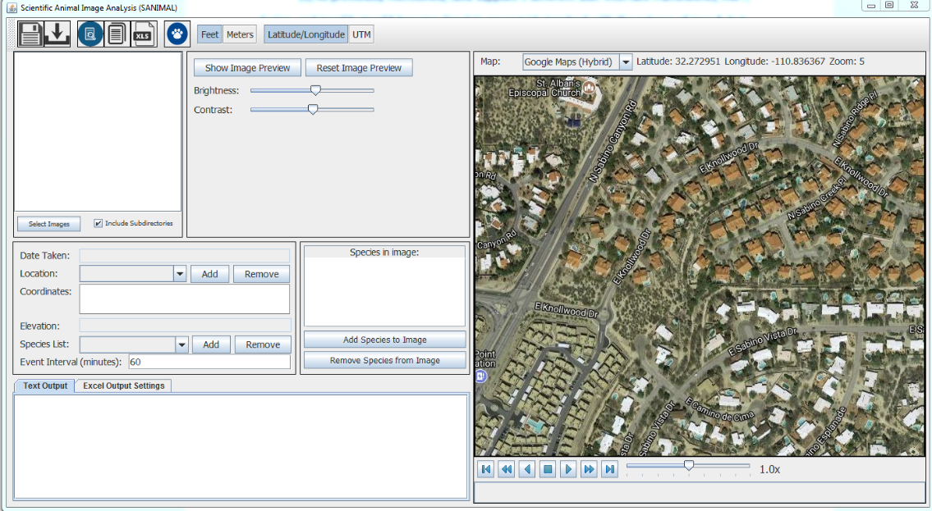

The user interface allows users to tag data using the following steps:

1. New locations are added to the program for each location data was collected at. A location consists of a name, a position, and an elevation.
2. A species is added for each species photographed in the data. A species only consists of a common name.
3. Images are imported using the select image button.
4. The user goes through each image and selects the location and species present in the image. The date and time taken are automatically read from the image EXIF metadata. This removes the requirement to use ReNamer to give images a specific name based on date and time.

One major problem encountered when tagging camera trap images is that night time photos may be very dark on the edges, making it difficult to see what species triggered the motion detector. If a user wants to tag a dark image using *DataOrganize*, an external program such as photoshop must be used to temporarily adjust brightness, contrast, and zoom of the image. To address this, *SANIMAL* can open a preview window of the image which supports temporary zoom, brightness, and contrast adjustments. This makes the tagging process much more efficient because users no longer need external tools to view dark images.

Another problem encountered is that users need a way to save their tagging progress to continue later without needing to keep the program open. If a user wants to save the current program state for later, *SANIMAL* has a save button which serializes its internal data model and saves it into a file. This file can then be opened through the program and all data such as species, locations, and images are loaded in.

It quickly became clear that researchers from all different kinds of regions were going to use this software, and therefore it was important to support different units of measurement. Elevation can be displayed in feet or meters and location can be displayed in latitude/longitude or UTM. When importing photos, *SANIMAL* asks the user whether they are entering location position in UTM or latitude/longitude, and if elevation is given in feet or meters. This small change made the software more usable than *DataAnalyze*, which only supported UTM and meters.

(3) The largest flaw inherent in *DataAnalyze* is its inability to clearly show analysis results. To start, *SANIMAL* could recreate the *DataAnalyze*. Recreating the output allowed *SANIMAL* to appeal to researchers used to the old system, and then build upon it. Because source code to *DataAnalyze* was not available, the *output.txt* was reverse engineered using Dr. Sanderson’sdocumentation as well as trial and error. In the reverse engineering process, many major bugs were discovered in *DataAnalyze* unknown to researchers at the time. *SANIMAL*’s algorithms fixed all bugs encountered.

To improve analysis, a map is included which displays a marker at each location on the map. The map allows selection from a list of various map providers like google maps, open street map, and virtual earth. Each provider provides a different set of map tiles which can be used to view street, satellite, or terrain data. This map allows playback of image data based on date and time taken. A progress bar lets users to watch the data like a video from the first image’s date to the last one. When the playback gets close an image’s date taken, an image thumbnail is displayed at the location the image was taken. This allows researchers to visualize where images were taken and what time throughout the study.

***SANIMAL* Swing Deficiencies:**

After some basic testing was done on the first version of *SANIMAL*, it was clear that many issues were not fully addressed, and additional features were requested. Most importantly, *SANIMAL* did not use a database backend which made it difficult to collaborate. Species and location lists needed to be created or loaded in manually every time the software was opened. Images were not directly tagged with EXIF metadata, so any species and location data were purely stored inside *SANIMAL* or a saved project file. This meant it was impossible to share images with other researchers without passing around project files. While the image tagging process was much faster than on the original *DataAnalyze* tool, the process was still tedious. Many mouse clicks were required to create a species and tag it onto an image. The analysis provided by *SANIMAL* was basic and, other than the map, the same as *DataAnalyze*. It was clear that the first iteration of *SANIMAL* was insufficient, and a second iteration of the software was needed.

***SANIMAL FX***:

To improve upon *SANIMAL*, it was clear thatthe UI and user workflow needed to be redesigned to support more modern features such as drag and drop and cloud-based setting storage. At the time, Java 8 had finally become standard in most Java applications. Java 8 came prepackaged with the new JavaFX graphics library which was meant as a replacement to Swing. JavaFX has many similarities to the C# UI such as the ability to perform data bindings and support the Model-View-ViewModel (MVVM) design pattern. The default controls also had a much fancier look than previous frameworks which made it much more appealing to users. Due to this, JavaFX was chosen as the UI framework for *SANIMAL*, and the software would be known as *SANIMAL FX*.

All issues discovered in *SANIMAL*, and *DataAnalyze* were addressed. More specifically, *SANIMAL FX* had the following advantages over original *SANIMAL*:

1. *SANIMAL FX* was written in JavaFX which allowed for simpler UI design
2. Metadata was directly embedded into images
3. Analysis in the form of CSV was easily made available with the introduction of queries
4. Security concerns were addressed with the introduction of authentication
5. CyVerse was chosen as the database backend to store images, instead of the local PC

***SANIMAL FX* in Detail:**

(1) With the introduction of JavaFX as the new Java UI standard, *SANIMAL* needed its UI completely rewritten. User interfaces are created using an XML like structure called *FXML*. *FXML* files are often referred to as the *View* component of a JavaFX application. *FXML* files have the advantage of being CSS compatible, meaning all UI elements may be targeted with a CSS selector and then visually styled. Each *FXML* file is associated with a single controller file, which is known as the *ViewModel*. This controller file receives events which originate from the *View* and can then update the *View* and/or the *Model* accordingly. The *Model* is comprised of Plain Old Java Objects (POJOs) which contain observable fields, known as properties. Observable fields simply notify any listeners whenever their state changes. Each Java primitive has its own property equivalent, while custom object types must be manually made into properties. The *ViewModel* can then bind properties in the *Model* to properties in the *View* which creates a kind of link. Whenever the *View* changes, the *Model* is automatically updated to reflect that change. If the *Model* is updated internally, the *View* will automatically reflect that change as well. The benefit of using the *Model-View-ViewModel* design pattern is that files are highly decoupled. More specifically:

- The *Model* knows nothing about the *View* or the *ViewModel*, it just supports a set of actions and notifies any listeners of those actions.

- The *View* knows nothing of the *Model*, it just defines the structure of the UI while forwarding any important events to the *ViewModel*.

- The *ViewModel* finally “glues” the *Model* and *View* together using bindings. It also updates the *Model* when any action events are received from the *View*.

(2) The original *SANIMAL* program stored all metadata information internally, which meant metadata was useless to any external application. *SANIMAL FX* writes metadata straight into the EXIF tags of the image file which ensures that any program can read the metadata. It also allows *SANIMAL FX* to automatically read metadata from previously tagged images.

(3) It was clear that the *output.txt* file created by *DataAnalyze* was lacking, and the analysis provided by the map in *SANIMAL* was not enough. JavaFX comes packaged with a 3D rendering API as well as a chart creation API. After asking many researchers and scientists about the charts/graphs they would like to see, it became clear that the list was endless. Each researcher wanted a slightly different permutation of the data and maintaining 25+ charts was unreasonable. Instead, it became much more important to provide the raw data in an easy-to-parse format, such as CSV. Researchers could then use their own programs and software libraries to create charts such as Excel, R, Java, Python, or JavaScript.

(4) When using the original *DataAnalyze* and *DataOrganize* programs, all image data was stored on PCs or Linux servers at best. These servers were often run by different organizations with various administrators which meant the data was not very secure. Each organization needed to secure their own data with their own permission system. In 2017, one researcher in the SNRE department stole many images with confidential location data on them and posted them publicly on the web. This incident showed the need for additional security to be present on the image data. To solve this issue, *SANIMAL FX* requires the user to make an account with CyVerse before logging in the use the software. CyVerse also provides many more features described below.

(5) CyVerse is a company with the goal, “To design, deploy, and expand a national Cyberinfrastructure for Life Sciences research, and to train scientists in its use” (cyverse.org). The company provides its users with a data store for terabytes of data, a high-performance execution framework for machine learning, and a way to authenticate users. *SANIMAL FX* makes use of all three of these features using a library called *Jargon*. *Jargon* is a Java-based implementation of the iRODS protocol which CyVerse uses as its interaction API. *SANIMAL FX* first makes use of the authentication API to make sure users can use the software. Once logged in, users tag their images with EXIF metadata and then upload the images to the CyVerse datastore. These images have permissions applied to them which ensures that no unwanted users can see the images or the image metadata. Images are indexed by metadata tags which allows them to be queried by the high-performance execution framework. These queries are then converted into CSV, where researchers can perform their analysis.

***SANIMAL FX* design challenges (UI):**

The first UI the user is presented with is the log in screen. A screenshot is shown below:

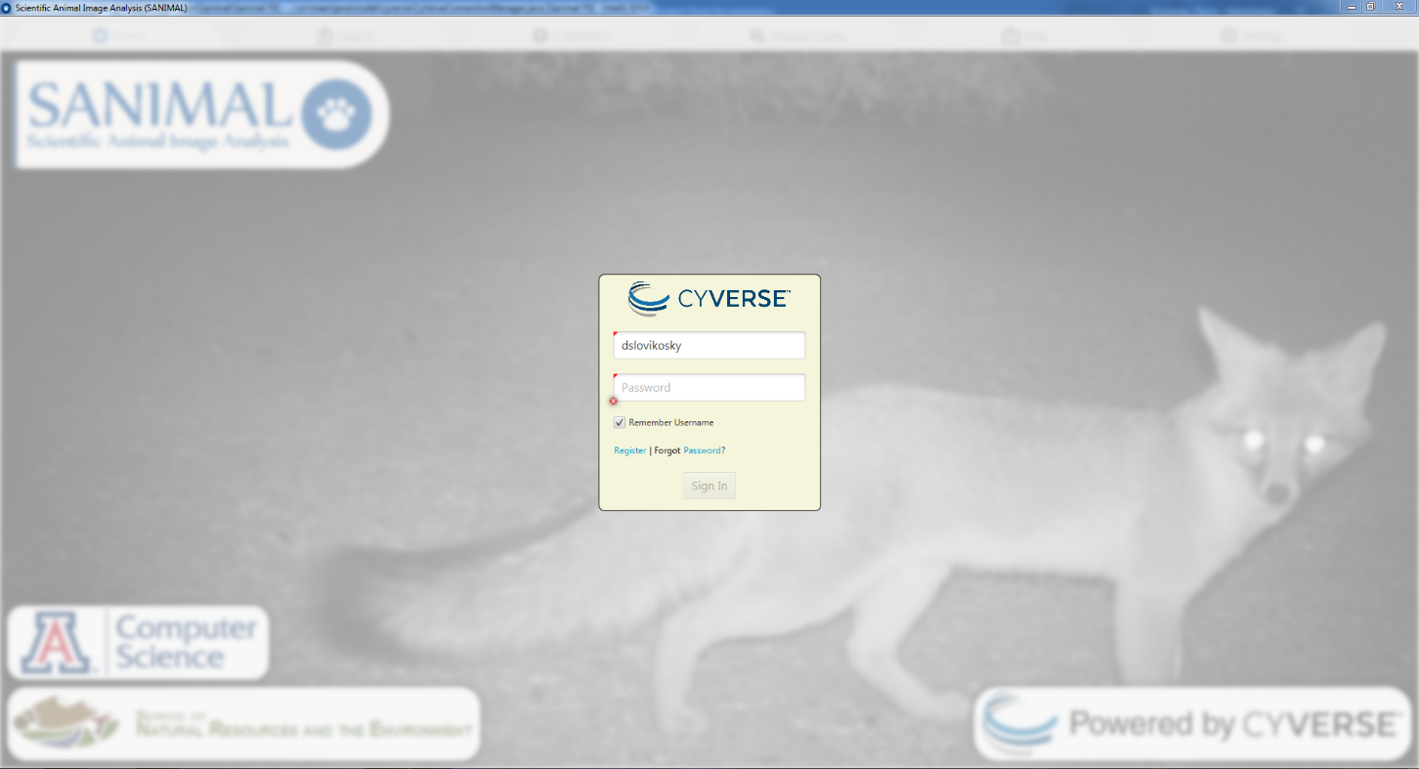

The login UI features a login username and password as expected. There is a checkbox which allows the user to remember the username for the next *SANIMAL FX* login. There is no “Remember Password” checkbox because remembering passwords is difficult to do without storing the password in plain text. Encryption needs to be used and that can be challenging to implement. The UI also features register and forgot password links to CyVerse’s website. After logging in, the user is brought to the home screen which features 6 tabs on top. Each tab serves a specific task in the workflow of the software:

* **Home tab** - The software starts on when the user logs in, doesn’t functionally do much other than credit developers
* **Import tab** – First functional tab used for loading photos into the program, and then tagging them with metadata such as species and location
* **Collections tab** – Next logical step after tagging photos, used to upload images to a project (also known as a collection) as well as download existing uploaded images for editing. Also used to edit collection permissions
* **Analyze/Query tab** – Final step after uploading data, allows users to query images uploaded given a set of constraints or filters
* **Map tab** – Utility tab which shows all locations on top of Google Maps
* **Settings tab** – Utility tab which allows the user to change various settings like date and time format

**Home Tab:**

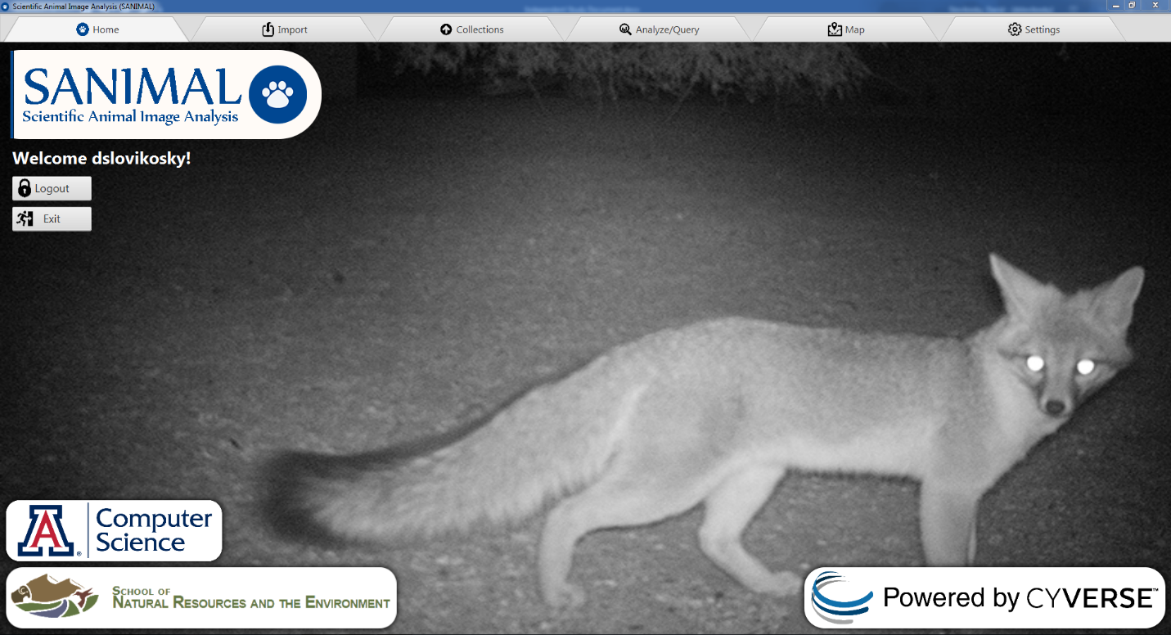

The bottom of the UI features links to the University of Arizona Computer Science and School of Natural Resource and the Environment links who developed *SANIMAL FX*. It also has a link to CyVerse’s website. The home UI also has an exit button to exit the application, and a logout button. Users requested a logout button when testing, but the button has the same function as the exit button.

**Import Tab:**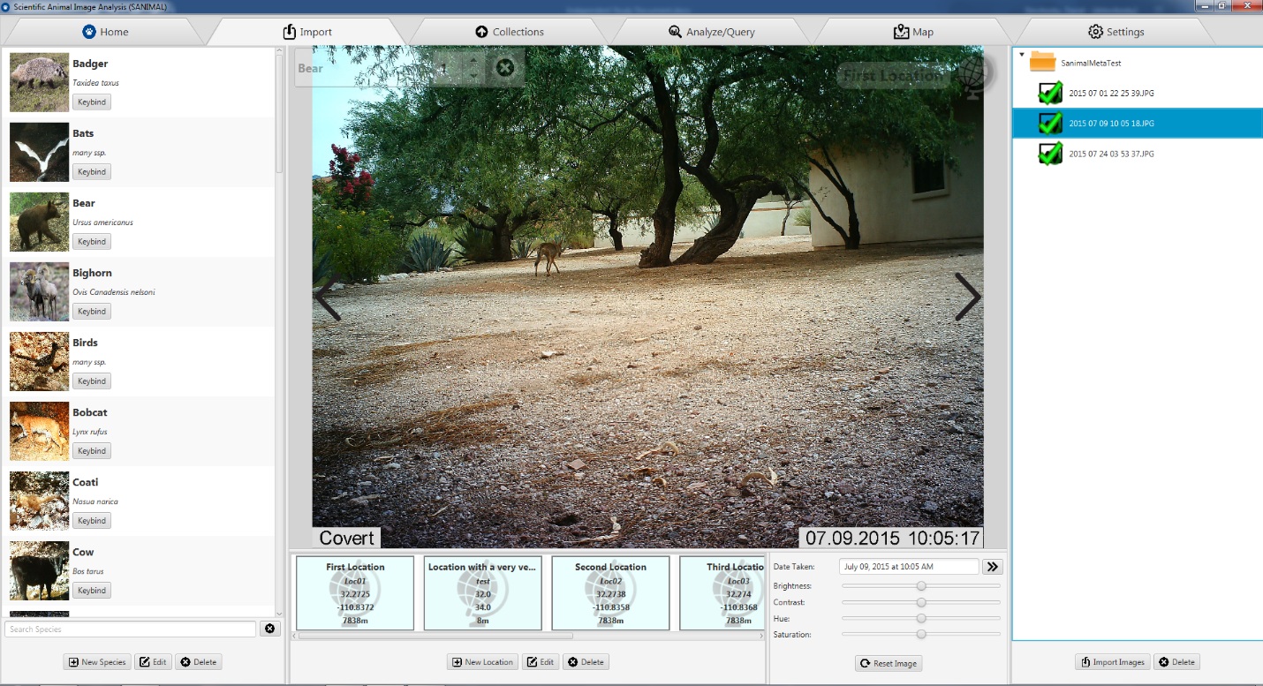

The import tab features a species panel on the left side. Here users can see their own customizable list of species. A species entry is made up of the following data:

* Common name
* Scientific name
* Icon web URL
* Key bind button (Used to “hotkey” a species for quick tagging)

The right side features the image panel, where all imported images are stored. Images icons change reflecting their status.

* Untagged – Image icon is the default
* Location tagged – Image icon shows a location marker on the right side
* Species tagged – Image icon shows a paw marker on the left side
* Species and Location tagged – Image icon shows a paw marker and location marker with a check mark over top

Clicking an image shows a preview of that image in the center preview panel. The center preview panel shows the current list of species in the image on the top left, and the location the image was taken at on the top right. Scrolling with the mouse allows for zooming in and out of the image. The bottom panel shows a list of locations on the left, and temporary image adjustments on the right. Temporary image adjustments were requested to help tag dark photos where species may be difficult to distinguish. Previously researchers often needed to open images in a third-party tool such as Photoshop, but now these adjustments were built directly into *SANIMAL FX*. These temporary adjustments include:

* Brightness
* Contrast
* Hue
* Saturation

The date and time the image was taken is also shown above the adjustments. The “date shift” button to the right of the date taken allows users to modify the date and time the image was taken. This is useful when cameras are incorrectly configured and store incorrect dates on images. Users tag photos by drag/dropping species and locations onto the center preview panel or specific images on the right panel. Locations may also be dropped onto a directory in the right panel to tag all images in that directory with the same location. EXIF metadata is automatically written to disk whenever a change is detected on an image.

**Collections Tab:**

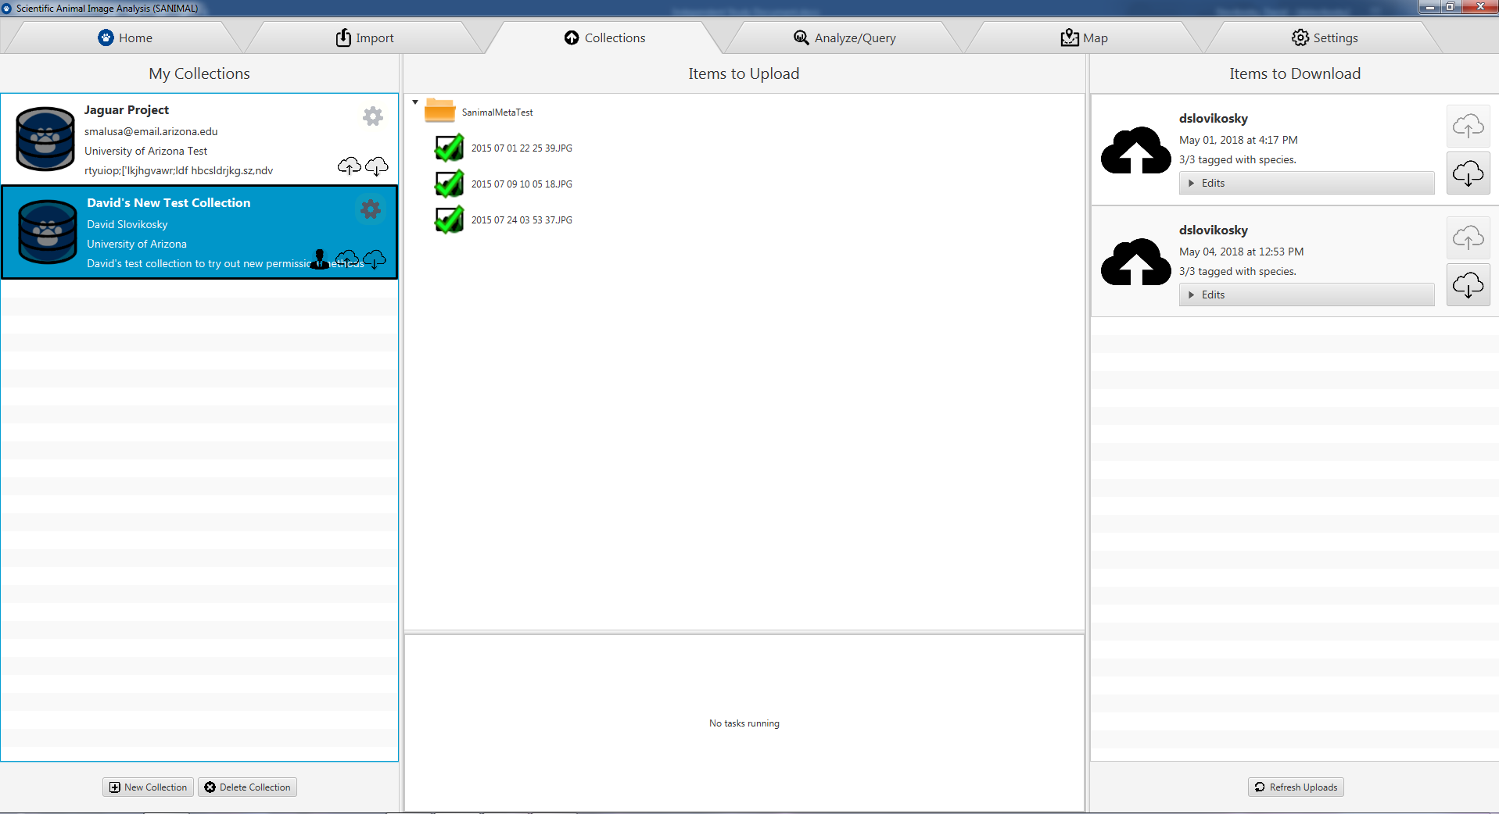

The collections tab shows a list of collections the current user is a part of on the left panel. The collection entry has the following fields:

* Name
* Contact Information
* Organization
* Description

The currently logged in user’s permission is shown below the gear on the right side of each collection entry. The profile icon means the current user owns a given collection. The cloud with an up arrow means the user can upload images to a collection, and the cloud with a down arrow means the user can query or read images from a given collection. The center tab shows a list of imported images and their statuses. Directories can be dragged from this center list onto a collection to begin the upload process. The progress of currently uploading images is displayed on the bottom. The right side of the collections tab contains a list of uploads from other users. Here users can download other users’ uploads and modify them in case there were errors.

**Analysis/Query Tab:**

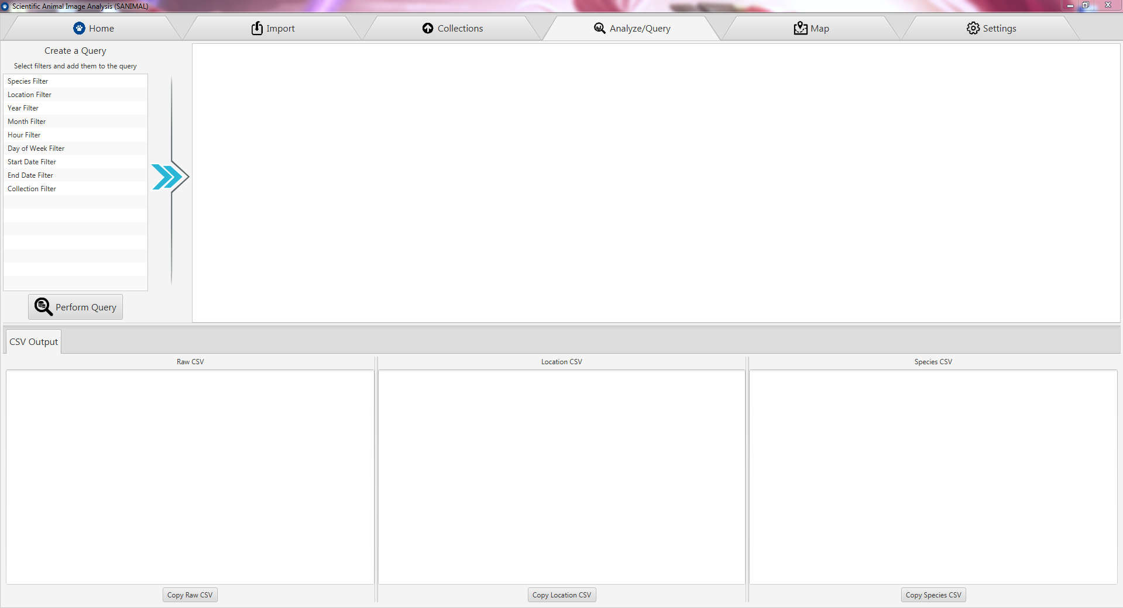

The analysis/query tab is responsible for creating SQL queries against uploaded data on CyVerse. The top left features a list of filters that can added into a query, and the right side shows a list of specific filter settings. After the user adds a list of filters and customizes each one they can press “perform query” which queries CyVerse. The result is returned as a CSV on the bottom.

**Map Tab:**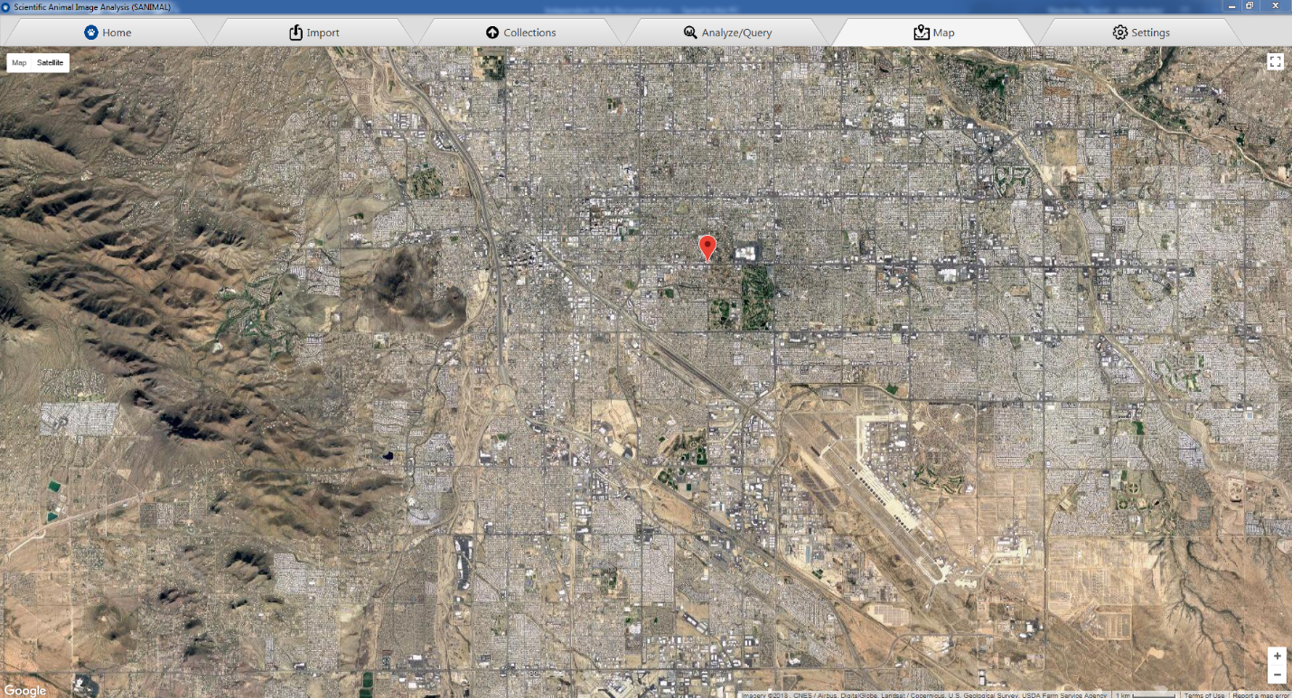

The map tab allows users to visually see their locations on a map. The map data is provided by Google Maps. This also allows for double checking of location lat/long coordinates to ensure the are in the correct locations.

**Settings Tab:**

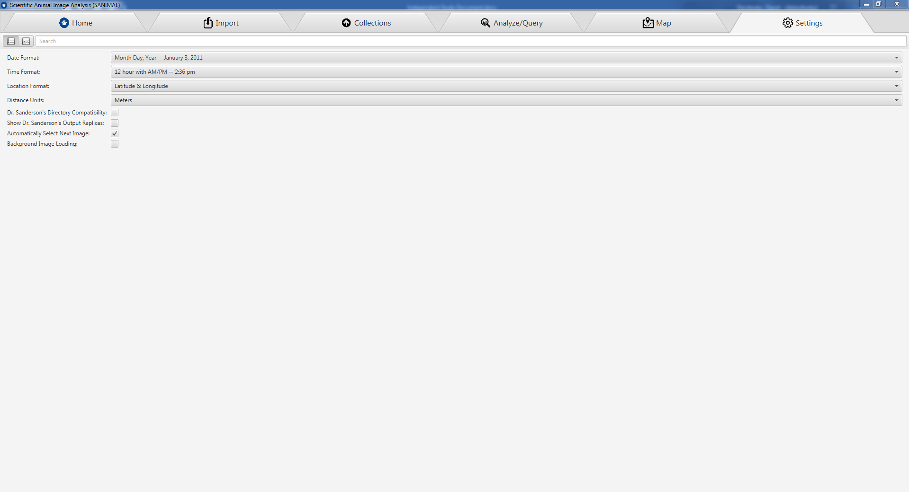

The settings tab contains 8 settings the user can adjust to help make the program easier to use. These 8 settings are:

1. Date format (ISO/Month Day Year/etc)
2. Time format (24hr/AM-PM)
3. Location format (UTM/Lat long)
4. Distance units (Feet/Meters)
5. Dr. Sanderson’s Directory Compatibility – Allows importing legacy data in the directory structure format specified by *DataOrganize*
6. Show Dr. Sanderson’s Output Replica – Shows the *output.txt* equivalent of the data returned from the SQL query on the Analysis/Query tab
7. Automatically Select Next Image – Allows the user to automatically jump to the next image whenever tagging species on an image. This speeds up the tagging process considerably
8. Background Image Loading – Places the loading of images onto a separate thread to reduce performance impact of loading images off a slow SD card or hard drive.